West-Coast Recess/Lunch –Please Dress for the Weather!
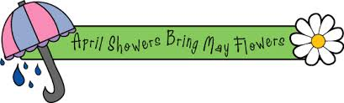
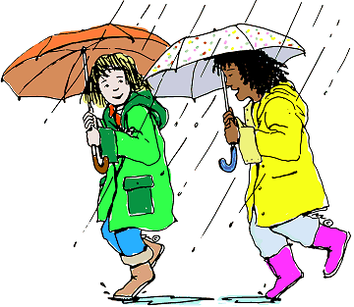
At Glenayre we believe it is healthy for kids to get outside throughout the day for fresh air and exercise. Living on the West Coast we know that our climate contains a consistent amount of rainfall especially throughout the winter months. It makes sense that in our climate we are well prepared to be outside in the rain. Given that students will be outside for lunch and / recess even when it’s raining it is important to send your child to school well prepared.

Being prepared for the weather
We know that if kids are well prepared to be outside in the rain they actually enjoy it. As long as they stay dry and warm there is a great deal of fun to be had in all kinds of weather. To be prepared to be outside in the rain it is important for your child to have:

- A rain coat or water resistant covering
- Rubber boots so they can enjoy the puddles (if you are able to provide them with a pair to keep at school that would be perfect)
- “Muddy Buddies” – rain pants they can quickly slip over their clothes (much like they would snow pants)
- An umbrella
- A rain hat or coat with a hood
- A change of clothes just in case. (sweatpants, sock, underwear, t-shirt)

Rainy Weather FAQ

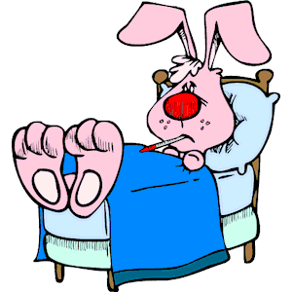
I am concerned that my child will get sick being out in the rain.
It is not cold that makes us sick but rather viruses. “People get sick more often in the winter because they are exposed to each other more in the winter than in the summer. When it is cold outside people tend to stay inside and are more likely to spread germs to one another” (from "Does Cold Weather Cause the Cold or Flu?”). Turns out that getting outdoors is more likely to protect our kids from illnesses than keeping them indoors.

My child has been sick but is now returning to school. Can he stay inside today?
We are quite reluctant to allow this for a couple of reasons. First, if your child is still not quite better it would be better to keep them at home until they are 100% ready to function fully at school. If he is too sick to go outside he is also probably too sick to get through the day’s work successfully – give him another day of rest. Secondly, we have very limited supervision inside so if more than a couple of kids are requesting this it becomes problematic.
We do make exceptions to this based on special circumstances so if you want to chat about your child’s specific health conditions please phone me and we can chat about your concerns.

Why don’t you keep them in – they would be far more comfortable – it doesn’t seem fair!!
We are concerned that if we set things up for our kids to avoid inclement weather by staying indoors we are teaching them that they need to protect themselves from it. The habits we set up with our kids as they grow up tend to last into adulthood. Rather than feeling that they need to stay indoors we want to encourage them to find ways to enjoy the rain. We also are fortunate to have large undercover areas for students to get out of the rain if they wish.
Students are very happy when it rains as they are busy constructing canals, dams, and islands so they are happy when the rain arrives to fill them. These types of imaginative play are very healthy learning experiences for our kids!!
Another reason why it is so important that our kids go outside is that it is extremely difficult for most of them to focus on their school work in the afternoons when they have not had the opportunity to get some fresh air. In the past when we used to keep kids inside more routinely due to rain our students struggled through their afternoons.

Are the children ever allowed to stay inside due to the weather?
We occasionally have weather conditions that are unreasonable to expect students to stay outside in. These days include hard, driving rain with extreme cold or wind. In these situations we intend to declare it an in day however we don’t expect to have more than 2 or 3 of them a year.
Additional Resources
- “Last Child in the Woods author on how outdoor play helps children thrive”
- “Children should be allowed to play in the dirt”

